## Custom Email Notifications Setup Based on Thresholds Context:

To illustrate the email notification setup, we utilize two key tables: QUERY_TIME and REFERENCE_TIME.

The QUERY_TIME table captures essential details such as Time Elapsed for each query and associated warehouse names. Conversely, the REFERENCE_TIME table stores corresponding thresholds for each warehouse.

A Stored Procedure is implemented to monitor queries that surpass their designated threshold times. When such an event occurs, an alert is triggered. A designated Task invokes this Stored Procedure.

**Email Integration:**

To send an email from Snowflake we need to set email integration.

SET emailAddress = '********@kipi.bi';

CREATE OR REPLACE NOTIFICATION INTEGRATION

SF_Email_Notifications

TYPE=EMAIL

ENABLED=TRUE

ALLOWED_RECIPIENTS=($emailAddress)

COMMENT = 'Snowflake Email Notifications';



This SQL query sets up a notification integration named "SF_Email_Notifications" that sends notifications to the email address stored in the emailAddress variable. The integration is enabled and configured to send notifications when certain events occur in the Snowflake database environment.

SHOW INTEGRATIONS;



The SQL query is used to retrieve a list of all the integration objects that have been created in the database

**Stored Procedure:**

create or replace procedure email_sender()

RETURNS STRING NOT NULL

LANGUAGE JAVASCRIPT

AS

$$

{

var query_ids = [];

var alert_count=snowflake.createStatement({ sqlText:`SELECT QUERY_ID FROM QUERY_TIME JOIN REFERENCE_TIME ON QUERY_TIME.WAREHOUSE_SIZE = REFERENCE_TIME.WH_SIZE WHERE QUERY_TIME.TOTAL_ELAPSED_TIME > REFERENCE_TIME.TIMEOUT_1`});

var excute_count=alert_count.execute();

while (excute_count.next()) {

query_ids.push(excute_count.getColumnValue("QUERY_ID"));

}

var output = "";

for (var i = 0; i < query_ids.length; i++) {

output += query_ids[i];

if (i < query_ids.length - 1) {

output += "\n";

} }

var alert_stat=snowflake.createStatement({ sqlText:`call system$send_email(

'SF_Email_Notifications',

'********@kipi.bi',

'[Snowflake Email Sending Test]:Test.',

'Queri_Ids: ''` + output + `''.End Time: ' || CURRENT_TIMESTAMP() || 'UTC \nPlease check the above:' || ` + query_ids.length+` || 'Queries. They exceeded the Threshold limit.'

);`});

var excute_state=alert_stat.execute();

return 'success';

}

$$;

This stored procedure is designed to perform the following tasks:

* The email_sender stored procedure checks the QUERY_TIME table to identify queries that have exceeded their threshold execution time based on the information stored in the REFERENCE_TIME table.
* It retrieves the query IDs from the queries that exceed the threshold and constructs a formatted message containing these query IDs.
* It then uses the system$send_email procedure to send an email notification. The email is sent using the email integration named 'SF_Email_Notifications'.
* The email contains information about the queries that exceeded the threshold, the current timestamp, and the total number of queries that exceeded the threshold.

In this case we have used QUERY_TIME table as the main table, REFERENCE_TIME table as a threshold reference table, QUERY_TIME.TOTAL_ELAPSED_TIME column as query run time and REFERENCE_TIME.TIMEOUT_1 column as threshold time but the users can customize the tables according to their needs.

**Task:**

Create or replace task task_email_sender

warehouse=COMPUTE_WH

schedule='USING CRON 30 11 * * * UTC'

As call email_sender();

alter task task_email_sender resume;



This block of code creates a Snowflake task named “task_email_sender” that is scheduled to run at 11:30 AM UTC using a CRON expression. The user can update this schedule to send the notifications for a different frequency. The task uses the COMPUTE_WH warehouse and executes the email_sender() stored procedure. After creating the task, it is immediately resumed, meaning it is set to start executing according to the specified schedule.

**Check Emails Sent:**

 SELECT CREATED

,PROCESSED

,MESSAGE_SOURCE

,INTEGRATION_NAME

,MESSAGE

,STATUS

FROM TABLE(Snowflake.information_schema.notification_history(integration_name => 'SF_Email_Notifications'));



The result of this query will be a result set that includes the selected columns for each notification in SF_Email_Notifications. This information can help you track the history of email notifications sent through this integration.

Sample Screenshot of the email received from Snowflake

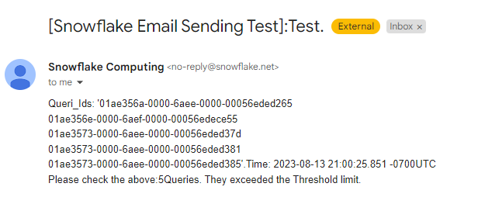

Attaching the threshold limit sheet for reference ([link](https://docs.google.com/spreadsheets/d/1ASj9yhXK3HbSpxVkJDMY4nUwVvypHxy5f5S40m3Io7E/edit#gid=1407023218)).